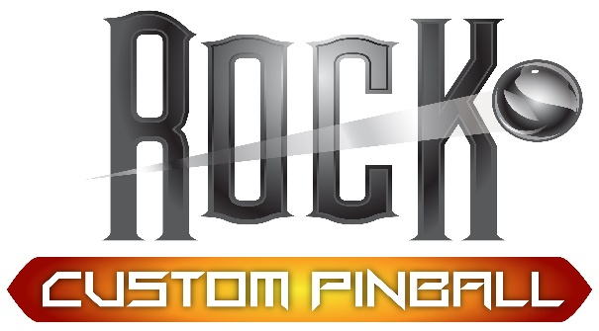

Instructions for Game on Bluetooth Back-panel lighting mod:
- Locate your backbox key
- Remove back glass (with the power off)
- Remove lockdown bar
- Remove Playfield glass
- Clean the inside the cab where the led’s will run. This is directly under the backbox and a few inches back from where the channel that holds the glass is located.
- You may need to lift your playfield to install, just raise the PF and set the hold bar or rest on the stand depending on your machine
- Peel and stick the leds inside the back of cab be sure to use the extra double-sided tape as extra adhesion is often required.
- Plug the bluetooth connector into the led’s the arrow needs to align with the Black or White wire. Plug the connector to the Game On system. If you are running multiple Bluetooth mods be sure to turn one off in the app to adjust the other.
- Secure all wiring
- Follow instructions for the Bluetooth remote, download the app and play with it. It will take awhile to get used to how it works
